## Music Workshops in Dundee Schools 2002-2019

Dundee Chamber Music has been sponsoring music workshops in Dundee schools since 2002.

Every year one or two of our ensembles visit a local school to give the pupils a workshop in some of the aspects of playing a musical instrument and enjoying classical music. This can take the form of coaching individuals or small groups of pupils who have advanced beyond the beginners’ stage, or can be aimed at developing the ability to listen to and enjoy classical music. The aim of the workshop is agreed between the musicians and the school beforehand.

In season 2014-2015 a workshop was given by Alison Green, bassoonist with the Scottish Chamber Orchestra under the auspices of SCO Connect, the Scottish Chamber Orchestra's Creative Learning Department working in partnership with Dundee Instrumental Service. On that occasion, instead of pupils from just one school being involved, wind players from a number of Dundee schools were guided not only on some aspects of playing a wind instrument but in ways of projecting oneself in front of an audience.

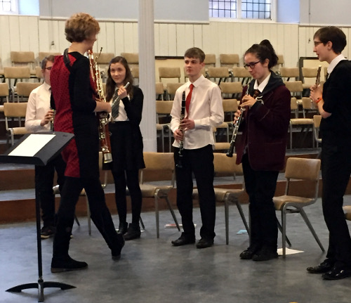  
Alison Green of the SCO Wind Soloists showing how it's done

Whatever the format, our artists have always regarded these workshops as important opportunities to enthuse school-age children in classical music. Meeting professional musicians shows the pupils what reward and real pleasure can be obtained from playing an instrument, both privately and socially as in an orchestra. For all pupils, even those who have never lifted an instrument, the control, the precision and the volume of sound produced by a small group of professional musicians can be a revelation.

So important do many performers regard this educational role that most ensembles, and soloists, have designed workshops specifically for schools. The schools are also very enthusiastic: over the last decade all but two secondary schools in Dundee as well as some in Angus have accepted one or more of our music workshops, and these occasions have proved popular with pupils and appreciated by the music staff of the schools.

Dundee City Council abolished music tuition charges in 2013 and at present one in eight city pupils is learning to play an instrument. With Dundee Education Department playing such a major role by providing free music lessons, it is to be hoped that Dundee’s pupils of today will become tomorrow’s enthusiastic music-lovers and performers.

### School Workshops held since the 2002 - 2003 season

|  |  |  |
| --- | --- | --- |
| Date | School | Ensemble |
| Nov. 2002 | Grove Academy | Douglas Boyd (oboe) & Susan Tomes (pno) |
| Jan. 2003 | Dundee High | Florilegium (flute, violin & cello) |
| Nov. 2003 | Monifieth High | Pavao String Quartet |
| Feb. 2004 | Lawside Academy | Academia Wind Quintet of Prague |
| Nov. 2004 | Morgan Academy, Baldragon Academy | Dante String Quartet |
| Jan. 2005 | Carnoustie High | St Petersburg String Quartet |
| Jan. 2006 | St Saviour’s High | Olivier Ensemble (clarinet, cello & piano) |
| Mar. 2006 | St John’s High | Emperor String Quartet |
| Jan. 2007 | Harris Academy, Grove Academy | Carducci String Quartet |
| Jan. 2008 | Menzieshill High | Royal String Quartet |
| Feb. 2009 | Baldragon Academy | London Concertante (wind members) |
| Nov. 2009 | Morgan Academy | Sarah Francis (oboe) & Tagore String Trio |
| Feb. 2010 | Carnoustie High | Carducci String Quartet |
| Dec. 2010 | St Paul’s Academy | Solstice String Quartet |
| Mar. 2011 | St John’s Academy | Atrium String Quartet |
| Dec. 2011 | Grove Academy, Harris Academy | Pure Brass |
| Jan. 2013 | Monifieth High, Dundee High | Navarra String Quartet |
| Feb. 2014 | St Paul’s Academy, Menzieshill High | Doric String Quartet |
| Feb. 2015 | Dundee Council Music Education | Scottish Chamber Orchestra, Wind Soloists (Alison Green, Bassoonist) |
| Dec. 2016 | Grove Academy | Maxwell Quartet |
| Feb. 2018 | Claypotts Castle PS | Cavendish Ensemble |
| Feb. 2019 | Victoria Park PS | Rautio Piano Trio |

## Financial Support

Dundee Chamber Music is most grateful to the Leng Charitable Trust which financed our workshops until 2008. The William Leng Fund and Enterprise Music Scotland have also given us generous support from time to time. The workshop held in February 2015 was financed by SCO Connect and Dundee City Council. Workshops since then have been financed by a donation from two of our members.